File 12_azone_hhsize_targets.csv
April 10, 2026
Definition of the Input File
VisionEval (https://visioneval.github.io/docs/model-inputs.html) explains that this file contains information on non-group quarters households and provides household-specific targets for the population synthesizer. This file contains two attributes:
- AveHhSize: Average household size for non-group quarters households
- Prop1PerHh: Proportion of non-group quarters households having only one person
For example, the data below suggest that households in Albemarle County and Charlottesville City are growing in terms of size, with the average household size increasing slightly in Albemarle (and the proportion of one-person households therefore dropping), and more dramatically increasing in the City of Charlottesville. By contrast, the average household size in Alleghany County is dropping (and the proportion of one-person households is increasing.)
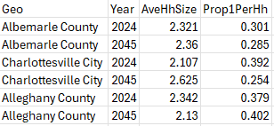
Possible Scenario
One possible scenario in VisionEval based on this input file is to examine how changes in household size may affect travel demand. For example, one would expect different travel impacts from a set of 50 households with two persons per household than from a set of 100 households with one person per household. The document Task 7.2 Simplified Scenario Development guide, available at A Playbook for Simplified Approaches for Creating Scenarios in VisionEval, explains that “While the base year populations often come from established data sources (e.g., Census) the future year population inputs can be modified to experiment with different assumptions about future population growth and demographic composition.”
Method Used for Virginia
Base Year
To obtain AveHhSize, Table B25010: Average Household Size of Occupied Housing Units by Tenure from the US Census Bureau was used. The base data is from 2023 and the total average household size was used. To obtain Prop1PerHh by Azone, Table S2501: Occupancy Characteristics from the US Census Bureau was used where again, the base data are from 2023. To calculate Prop1PerHh, this equation was used:
Prop1PerHh = $\frac{1 person households}{Total households}$
To convert these 2023 values to 2024, a short term trendline for the three years prior to the base data year (2020, 2021, and 2022) was developed, and Excel was used to calculate the slope of these data over the 4 years for each Azone, and added/subtracted that from the 2023 data. On average, this resulted in a small negative slope for AveHhSize and a small positive slope for Prop1PerHh.
Here is a snapshot of the intermediate file used to estimate the 2024 data for AveHhSize:
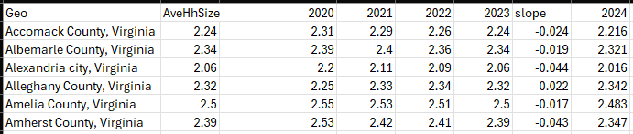
Forecast Year
The analyst has three different options for forecast year values.
- One approach is to assume no change. Although household sizes have in some cases been decreasing since the 1970s, there is no guarantee this trend will continue. Similarly, in locations where household sizes have increased, there is not a guarantee this trend will continue. Thus, the local analyst may thus replace the 2045 values with 2024 values (presuming no change).
- A second option is to presume that indeed this trend will continue. To make use of longer-term trends, data tables from the US Census Bureau were used for years 2019, 2016, 2013, and 2010, and then Excel was used to calculate the slope from 2010 to 2024, and this slope was initially used to predict the values for 2045 for each Azone going from 2019—that is, 26 years into the future to year 2045. However, this trend is likely unrealistic, as improbable values can result, such as values less than one, and sometimes negative, for average household size. A compromise was to add, for each Azone’s AveHhSize, the slope*15 to the 2019 value (rather than adding the slope*26 as done previously). This approach was used here.
- A third option is to use Woods & Poole 2045 household size values for Azones and then to adjust the one-person households. This third option has not yet been pursued but may be considered later in 2026.

Appendix
Other Census data sources may be used. For example, the 2023 DP02 table from the census website as of June 2025 (DP02: Selected Social ... - Census Bureau Table) contains average household size for each city/county, while the Prop1PerHh column may be found by adding the male householder living alone estimates with the female householder living alone estimates and dividing that by the total households estimates to get the proportion of non-group quarters households having only one person. A snapshot of the DP02 table is below:
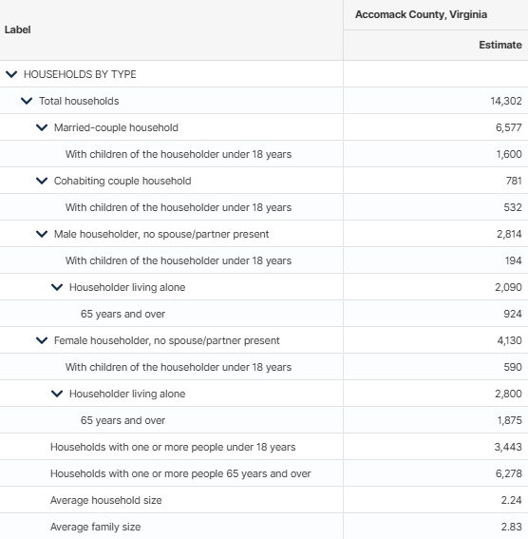
Scrap work

(Chapter 7 Model Inputs | VisionEval User Guide).

